**Acceptance and Commitment Therapy Introductory Workshop**

**Contact info:**

**Jason Luoma, Ph.D.,** [**jbluoma@gmail.com**](mailto:jbluoma@gmail.com)

**Jenna LeJeune, Ph.D.,** [**dr.lejeune@gmail.com**](mailto:dr.lejeune@gmail.com)

Portland Psychotherapy Clinic, Research, & Training Center

www.portlandpsychotherapyclinic.com

3700 N Williams Ave

Portland, OR 97227

Phone/Fax: 503-281-4852

**What is ACT?**

* A type of cognitive behavioral therapy that comes from a theory about how the human mind works.
* This theory and the research that supports it suggests that many of our normal, human attempts at problem solving can backfire and create needless suffering and distract us from our more important life paths and goals.

**The ACT Hexagon Model**



**The goal of ACT, put simply:**

* The aim of ACT is to create a rich, full and meaningful life, while accepting the pain that inevitably goes with it.

**The goal of ACT, more technically:**

* The goal of ACT is to increase **psychological flexibility**.
* Psychological flexibility has two components: 1) the ability to be psychologically present (i.e. aware, attentive, open to, and engaged in your experience); 2) the ability to control your behavior (e.g., what you do with your hands, your feet, and your mount) to serve valued ends
* Official ACT definition: Psychological flexibility is the process of contacting the present moment fully as a conscious human being and, depending on what the situation affords, persisting or changing behavior in the service of chosen values.

**Left side of Hexagon (acceptance/defusion)**

* Aimed primarily at disrupting narrow, inflexible patterns of behavior which interfere with valued action
* About undermining language where it tends to be unhelpful (in controlling private experience)
* Undermining avoidance
* About getting people untangled from useless or ineffective avoidance goals

**Right Side of Hexagon (values/committed action)**

* Aimed primarily at building broad, flexible patterns of behavior that allow persistence or change in the service of in valued directions
* About building language where it tends to be more useful (guiding physical action toward values)
* Building approach (appetitive)
* Constructive: About building patterns of action in the service of valued directions

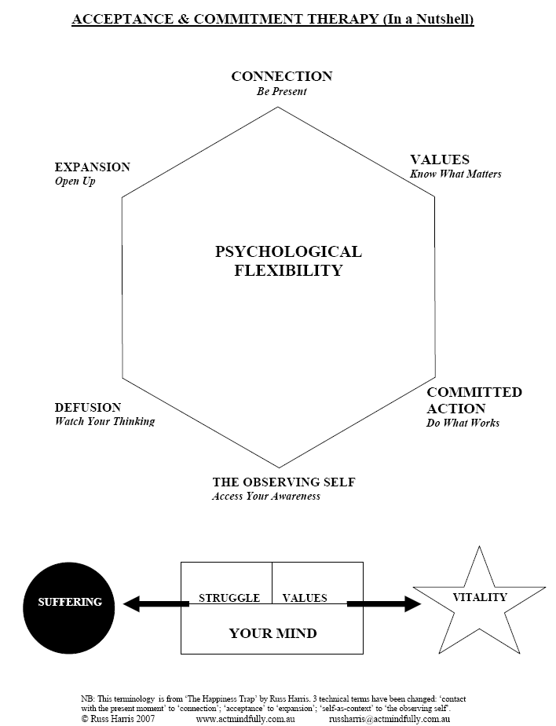

**The Six core processes of ACT:**

***1. Acceptance/Willingness***

Actively contacting psychological experiences directly, fully, and without needless defense

Definition: defused, open, undefended contact with the present moment, as a fully conscious human being.

Colloquial: ‘Opening yourself fully to experience, as it is, not as your mind says it is’

***2. Defusion***

Looking *at* thoughts, rather than *from* thoughts

Noticing thoughts, rather than being caught up in thoughts

Seeing thoughts as what they are, not as what they seem to be

Aim of Defusion is ***NOT*** to feel better, nor to get rid of unwanted thoughts

Aim of Defusion ***IS*** to reduce influence of unhelpful cognitive processes upon behavior; to facilitate being psychologically present & engaged in experience; to facilitate awareness of language processes, in order to enhance psychological flexibility

***3. Contact with the Present Moment***

Gives you important information about whether to change or persist in behavior

Enables you to ‘catch’ cognitive fusion ‘in flight’

Allows you to engage fully in what you are doing

***4. Perspective Taking Self (self-as-context)***

Use of perspective taking interventions and contacting a more flexible sense of self as a transcendant, consistent observer. This facilitates a healthy distance from fused thinking and a sense of space to experience whatever is there to experience. This is a process of flexible perspective-taking, not a thing: contact with ‘pure awareness’

***5. Values***

Chosen life directions

Not really a thing at all, but valuing is a quality of action, part of any purposive or intentional act

*‘Your heart’s deepest desires for the sort of person you want to be and the things you want to do in your time on this planet; in other words, what you want to stand for in life’*

Provide motivation & inspiration

Provide guidance for your actions

Give life meaning

Give a sense of abundance

Are different from goals

***6.Committed Action***

Overt behavior in the service of values

(may require skills training)

Committedaction is: values-guided, effective & mindful

Taking responsibility for patterns of action, building them into larger and larger units.

**ACT uses acceptance and mindfulness processes, and commitment and behavior change processes, to produce greater psychological flexibility.**